izFke v/;k;
'kks/k ifjp;


f}rh; v/;k;
lEcfU/kr lkfgR; dk v/;;u
,oa
iqujkoyksdu


r`rh; v/;k;
'kks/k fof/k] U;kn’kZ ,oa
midj.k


prqFkZ v/;k;
iznRrksa dk oxhZdj.k ,oa
fo’ys"k.k
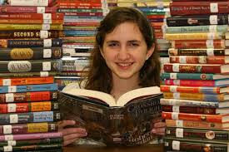

iape v/;k;
'kks/k ds fu"d"kZ] 'kSf{kd fufgrkFkZ
,oa
lq>ko


